LAB ASSIGNMENT V : HUERISTIC EVALUATION
SYSTEM EVALUATED : Naukri Job Portal Website (Figma Prototype)
Groups members NAME : Hussein Ebrahim
**Evaluation to be done by other Group
PART I : HUERISTIC EVALUATION BASED ON NIELSEN'S 10 GENERAL PRINCIPLES FOR INTERACTION DESIGN. (0 is lowest and 5 is highest)
S.No. | Heuristic Evaluation Parameter | Mention Violation if any | Severity 0-10 (0- minimum and 10 is maximium) | Ways to improve
1 | User Control: Interface will allow the user to perceive that they are in control | On jobs page there is no clear all option for filters and no breadcrumb so you have to untick every box one by one. | 3 | Put a clear all button next to All Filters and show the selected filters on top so they can be removed easily.
2 | Human Limitations: Interface will not overload the users cognitive, auditory and motor skills | Too much on the jobs page at once, 20 filter checkboxes + 8 popular job tags + job cards. Also the light grey text like 2 days ago and subscription starts from is very small and hard to read. | 4 | Keep less used filters like job type and salary collapsed by default. Make the small grey text a bit bigger and darker.
3 | Accommodation: The interface will fit the way each user group works and thinks (personas) | Employers only get a small For employers dropdown in the corner. | 2 | Make the For employers option more visible, like a proper button in the navbar so employers can find it easily.
4 | Linguistic Clarity: Interface will communicate as efficiently as possible | LPA is written everywhere but not explained anywhere, a fresher might not know it. Home page says 5 lakh+ jobs but jobs page shows 24,892 results. Spelling mistakes on services page, upto and Standout. | 4 | Fix spellings (up to, Stand out), add a small hint for LPA and keep job count same on both pages.
5 | Aesthetic Integrity :The interface will have an attractive and appropriate design | company logos are just letters in coloured boxes (G, M, A) so it looks unfinished. Login button in popup is orange same as Register. | 2 | Use real company logos and keep orange only for Register / main buttons.
6 | Simplicity: The interface will have a simple design | Home page is simple, search bar is the main thing. Only issue is the placeholder text gets cut off (Enter skills / designations / c) and the search box feels cramped. | 2 | Make placeholder shorter like Skills, designation or company, or make that field wider.
7 | Predictability :The interface will behave in such a manner that the user can accurately predict what will happen next | Company cards have a > arrow so you know they open but job cards dont have it, so not sure if clicking opens the job. Also the 34 new link below search doesnt say what it is. | 4 | Add arrow or view details on job cards also and write something clearer like 34 new jobs for your last search.
8 | Accuracy: Interface will be free from errors | Footer still says 2024. Companies page heading says Top companies hiring now but its showing all 10,053 companies. Salary and experience ranges overlap (0-3, 3-6 LPA and 1-3, 3-5 yrs) so 3 comes in both. | 5 | Update the year, change heading to All companies, and make the ranges not overlap like 0-3, 4-6.
9 | Technical Clarity: Interface will have the highest possible fidelity. | Logos are placeholders and social icons in footer are just text (f, in, tw, yt) instead of icons. | 3 | Replace with proper logos and social media icons.
10 | Fulfillment : The interface will provide a satisfying user experience | Bit too much push for paid stuff though, boost your career banner on home and exclusive discount on services page. | 2 | Tone down the paid service banners a little so it doesnt feel like an ad.
11 | Consistency: Interface will be consistent | Login button in header is blue outline but the one inside popup is filled orange. Home page navbar has no search bar but jobs, companies and services pages have it. Footer and nav are same everywhere which is good. | 4 | Use same style for same button everywhere and keep navbar same on all pages.
12 | User Support: Interface will provide additional assistance as needed or requested | Help centre is only in footer and toll free number only on services page. Login popup doesnt have forgot password. | 4 | Add forgot password and a small help icon in the header.
13 | Precision: The interface will allow the users to perform a task exactly | Location filter has only 5 cities and no search inside it. Salary and experience only in fixed ranges, cant set exact values. Only one sort option. | 4 | Add a search box in location filter and a slider for salary and experience.
14 | Forgiveness: Interface will make action recoverable | No forgot password, no show/hide password option in login, no clear all for filters. If user does something wrong its extra work to undo it. | 5 | Add forgot password, eye icon for password and clear all filters button.
15 | Responsiveness: The interface will inform users about the results of their actions and their interface status | There is no place where selected filters are shown above the results. | 2 | Show applied filters as small tags above the job list.
 | Total Score |  | 50 / 150 (avg 3.3 / 10)

**Attach Screenshots
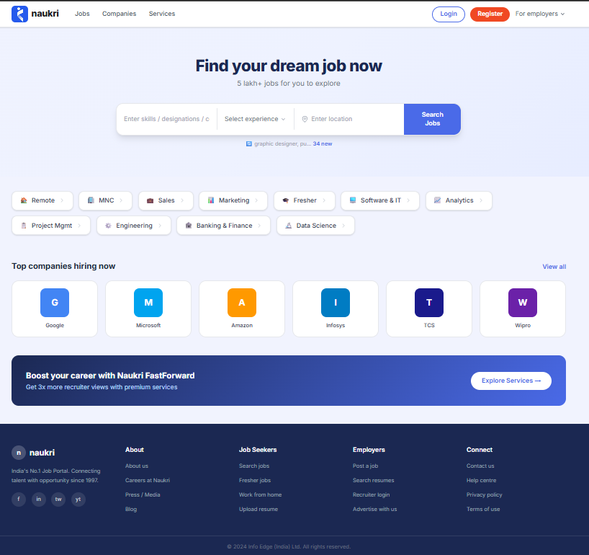
Fig 1: Home page
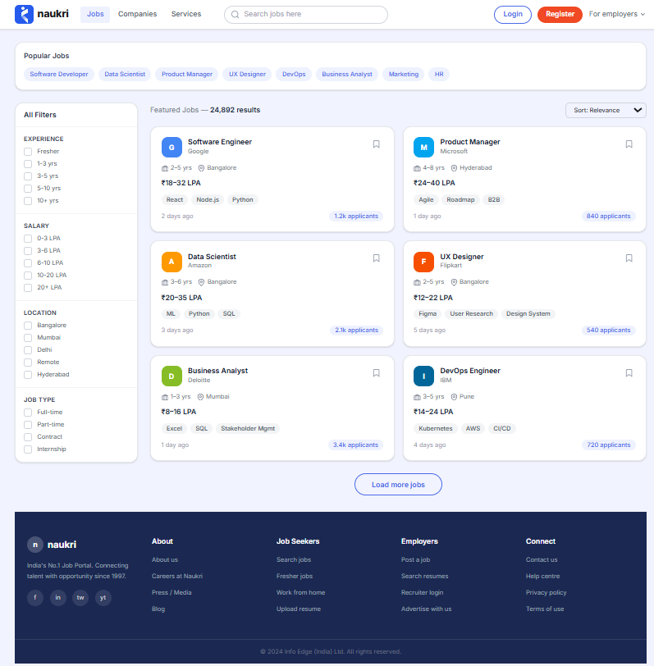
Fig 2: Jobs listing page with filters
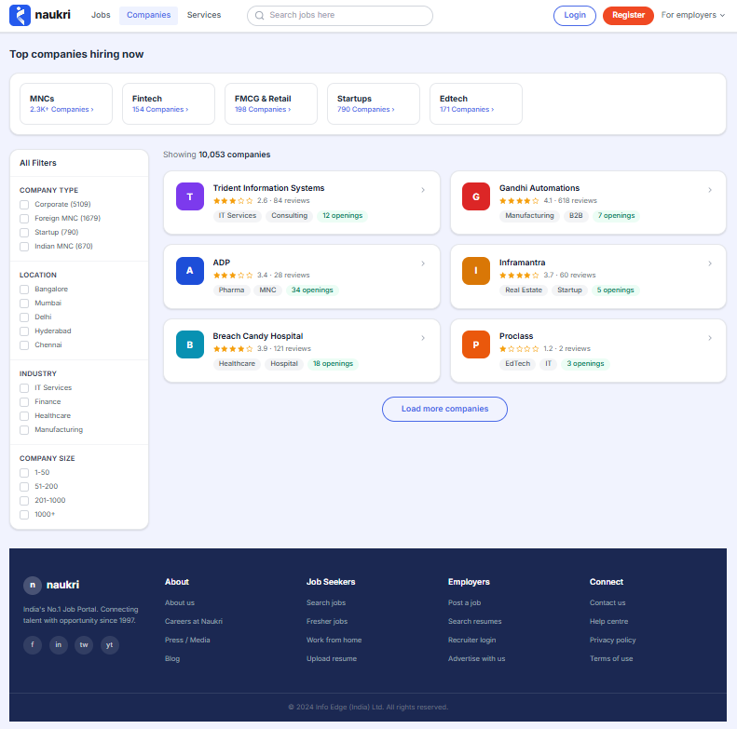
Fig 3: Companies page
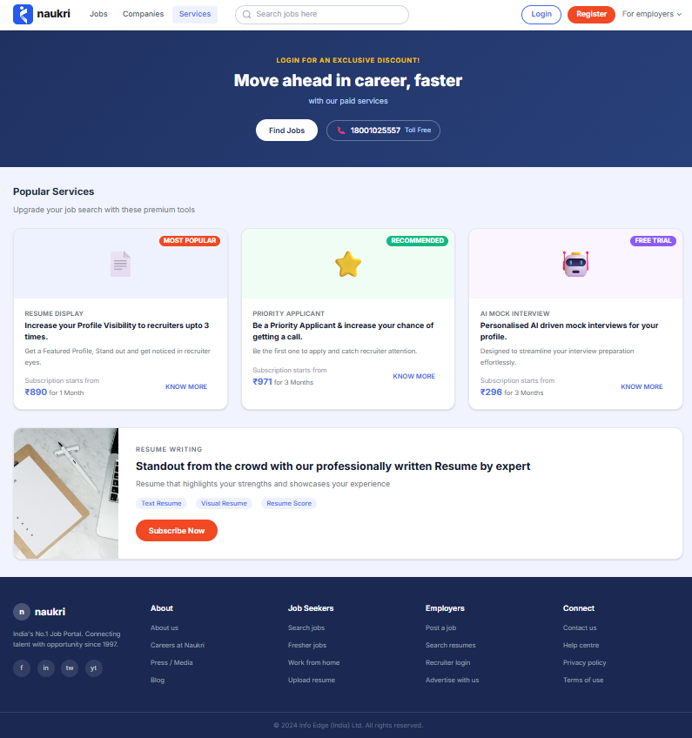
Fig 4: Services page
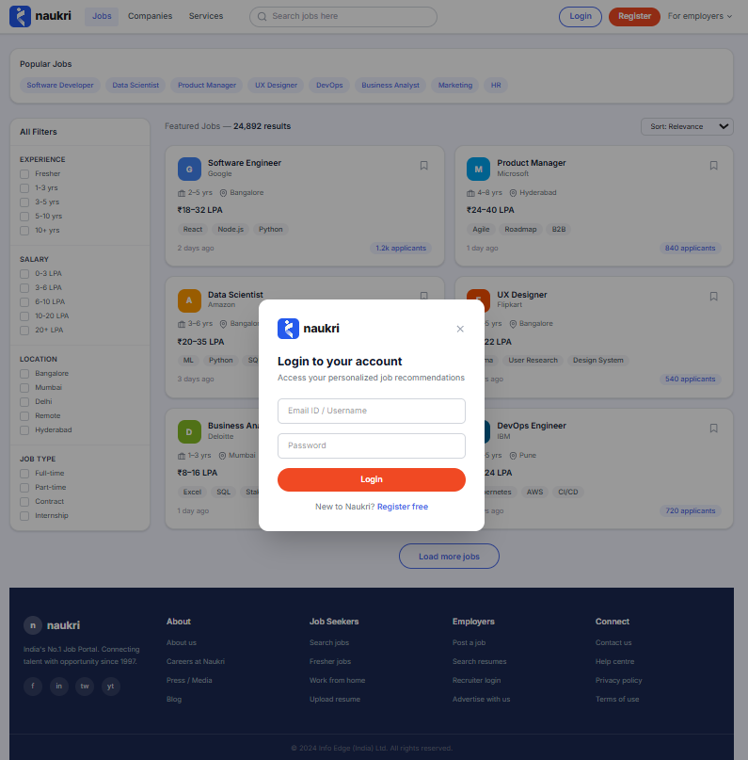
Fig 5: Login popup on Jobs page

PART II : List out any other points that you may have missed out . (Other than Nielsen’s Principles)

S.NO | OBSERVATIONS | COMMENTS
1 | Low contrast at some places, light grey text on white and the footer links on dark blue. | Should be checked for readability, at least 4.5:1 contrast.
2 | Company ratings with 2 reviews (Proclass 1.2) are shown same as ones with 618 reviews (Gandhi Automations). | Can mislead users, maybe show few reviews tag or hide rating below some minimum.
3 | Navbar search says Search jobs here even on the companies page. | On companies page it should search companies or say search jobs or companies.
4 | Category cards on top of companies page (MNCs, Fintech, Startups etc) do the same thing as the company type filter on the left. | Feels repeated, can remove one or merge them.

Students Evaluation Team : group that is evaluation Airline Booking

